Water Cycle Diagram Rubric
_____ Heading / Title (1 point)
_____ Draw some landscape and outdoor scenery. (10 points)
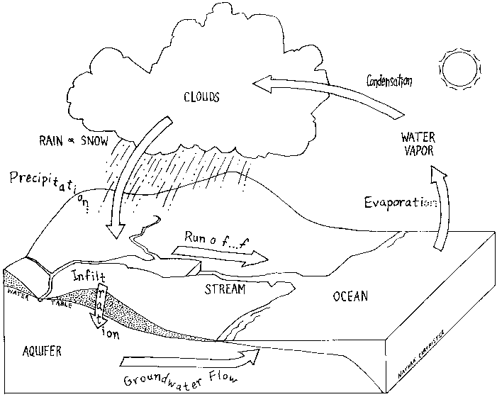
_____ Label the following parts: (10 points)
- sun
- evaporation
- transpiration
- condensation
- precipitation
- runoff
- infiltration
- stream
- ocean
- groundwater (aquifer)

_____ Draw arrows showing the flow of water through the entire water cycle. (3 points)
_____ Color the diagram (5 points)
_____ TOTAL = 29 POINTS
Water Cycle Diagram Rubric
_____ Heading / Title (1 point)
_____ Draw some landscape and outdoor scenery. (10 points)
_____ Label the following parts: (10 points)
- sun
- evaporation
- transpiration
- condensation
- precipitation
- runoff
- infiltration
- stream
- ocean
- groundwater (aquifer)

_____ Draw arrows showing the flow of water through the entire water cycle. (3 points)
_____ Color the diagram (5 points)
_____ TOTAL = 29 POINTS

