What is the water cycle?
What is the water cycle? I can easily answer that—it is "me" all over! The water cycle describes the existence and movement of water on, in, and above the Earth. Earth's water is always in movement and is always changing states, from liquid to vapor to ice and back again. The water cycle has been working for billions of years and all life on Earth depends on it continuing to work; the Earth would be a pretty stale place to live without it.
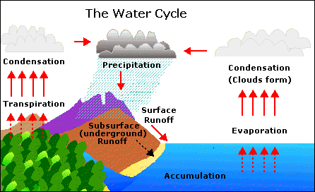
Where does all the Earth's water come from? Primordial Earth was an incandescent globe made of magma, but all magmas contain water. Water set free by magma began to cool down the Earth's atmosphere, until it could stay on the surface as a liquid. Volcanic activity kept and still keeps introducing water in the atmosphere, thus increasing the surface- and ground-water volume of the Earth.

A quick summary of the water cycle:
Here is a quick summary of the water cycle. The links in this paragraph go to the detailed Web pages in our Web site for each topic. A shorter summary of each topic can be found further down in this page, though.
The water cycle has no starting point. But, we'll begin in the oceans, since that is where most of Earth's water exists. The sun, which drives the water cycle, heats water in the oceans. Some of it evaporates as vapor into the air. Ice and snow can sublimate directly into water vapor. Rising air currents take the vapor up into the atmosphere, along with water from transpiration, which is water transpired from plants and evaporated from the soil.
The vapor rises into the air where cooler temperatures cause it to condense into clouds. Air currents move clouds around the globe, cloud particles collide, grow, and fall out of the sky as precipitation. Some precipitation falls as snow and can accumulate as ice caps and glaciers, which can store frozen water for thousands of years. Snowpacks in warmer climates often thaw and melt when spring arrives, and the melted water flows overland as snowmelt. Most precipitation falls back into the oceans or onto land, where, due to gravity, the precipitation flows over the ground as surface runoff.
A portion of runoff enters rivers in valleys in the landscape, with streamflow moving water towards the oceans. Runoff, and ground-water seepage, accumulate and are stored as freshwater in lakes. Not all runoff flows into rivers, though. Much of it soaks into the ground as infiltration. Some water infiltrates deep into the ground and replenishes aquifers (saturated subsurface rock), which store huge amounts of freshwater for long periods of time. Some infiltration stays close to the land surface and can seep back into surface-water bodies (and the ocean) as ground-water discharge, and some ground water finds openings in the land surface and emerges as freshwater springs. Over time, though, all of this water keeps moving, some to reenter the ocean, where the water cycle "ends" ... oops - I mean, where it "begins."

