The Water Cycle Website Review - USGS
Name__________________________________________________ Date__________ Hour____

Use complete sentences to answer the following questions about the water cycle:

- What does USGS stand for?

- What is infiltration?

- A spring is a place where water moving underground finds an opening to the land surface and emerges. Why does Florida have so many springs compared to some other states?

- Although an average cumulus cloud weighs around 998 million kg, how are they able to float up in the atmosphere?

- Geysers and volcanoes actually play a small part in the water cycle. Why?

- During an average growing season, how much water vapor can a tree transpire into the atmosphere?

- Oceans play a huge part in the water cycle. 97% of all water on Earth contains salt. Where did all of that salt come from?

- What is humidity?

- Where is most of the Earth’s freshwater located?

- How do lakes form?

- Explain three ways in which groundwater is helpful in nature?

- What animal makes the biggest impact on the water cycle? Why?

- What part of the water cycle is the most important for plants to absorb water?

- When precipitation falls to Earth, how does the water get back into the oceans?

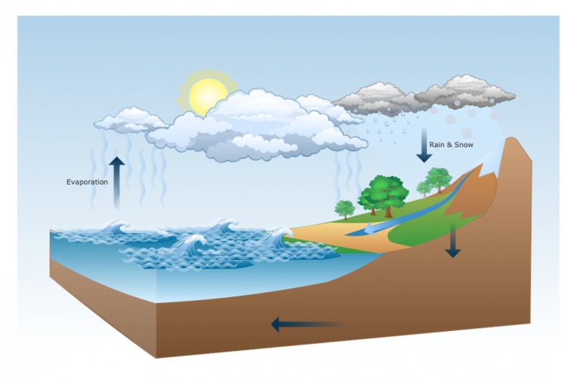
- How does condensation happen?

